Hellowin Project
[JANUARY] - 2019

[Hellowin Business Game]
Hellowin Project [JANUARY]
Personal Investment: $ 200.
People involved: Hippies
Materials produced: Postcards to be distributed in January as a sign of friendship and connection between friends.
Total collected for Hippies: $ 4,395.60
LenderBook Advantage: Disclose portal 30thmax.com
— Max Diniz Cruzeiro
#world #brasil

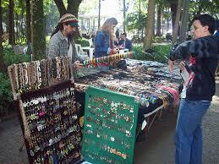

I ordered 8,000 postcards; in the form of a special lot for Hellowin. In Brazil the Hippies can sell each card for 55 cents.
— Max Diniz Cruzeiro
#world #brasil

If I consider that 70% of the Postcards will transit through the Post Office, it will yield to postal services up to $ 2,846.15.
— Max Diniz Cruzeiro
#world #brasil

The Hellowin event can also generate connections for express messages, express gifts, phone calls, and activation of the motel segment.
— Max Diniz Cruzeiro
#world #brasil

In Hellowin the businessman supplies all the materials for the Hippies to sell. The entrepreneur’s gain is with the publicity that is contained in the objects transacted by the Hippies. The entire fund raised by the Hippies is in the very segment of these street entrepreneurs.
— Max Diniz Cruzeiro
#world #brasil

Hellowin is given an opportunity for people to communicate and approach each other throughout January, so that the depth of contact will connect throughout the year.
— Max Diniz Cruzeiro
#world #brasil

At Hellowinter, friends join together on a literary platform and create a shared book, where each Friend expresses in no more than 5 pages a chapter he wishes to follow in his life history throughout the year. So throughout January Hellowin is part of reading who wants to schedule their year for people who truly care about living in a collective.
— Max Diniz Cruzeiro
#world #brasil
At Hellowinter, friends get together on a platform for each one to record a maximum of 10 minutes of sounds, images and video of the ties that they truly want to care about throughout the year.
- Max Diniz Cruzeiro
#world #brasil

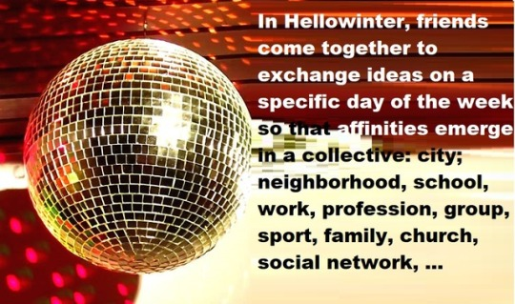

At Hellowinter, friends come together to exchange ideas on a specific day of the week to discuss projects that can be built together and measure the synergies of purpose for social bonds to grow.

#world#brasil

Max Diniz Cruzeiro
QNJ 30 CASA 30 Taguatinga Norte – Brasília/DF – Brazil
CEP: 72140-300
LenderBook Company
www.lenderbook.com
www.lenderbook.com/app
www.30thmax.com
+55 (61) 99967-3008 / +55 (61) 3475-6777 ----------- > Language Phone: Portuguese.
contato@lenderbook.com / lenderbook@gmail.com

