“Hellowin for journalism can be filling out a subscriber profile questionnaire by professional characteristics, in the formation of a book with personalized information that the professional must insert to be well prepared throughout the year.”
— Max Diniz Cruzeiro

#world #brasil

“[Example journalist book] A person with an economic profile wants a book with all the material from the last 5 years of sectors that have had economic growth.”
— Max Diniz Cruzeiro
#world #brasil

“The journal book can be by mechanical extraction (value less aggregated through searches by words contained in texts), or mechanical and manual extraction (more accurate value because there is a need to evaluate the contents migrated through a specialist).”
— Max Diniz Cruzeiro

#world #brasil

“Literary works in journalistic format must have a customized format, printing only after sale. One can think of setting up prospecting companies for books that portray shared views of various journalistic media.”
— Max Diniz Cruzeiro

#world #brasil

“The same work can be offered for video content. With two options: cut through a keyword located in the audio where all content will be part of a CD; cut through keyword located in the audio that only fragments of interest are edited.”
— Max Diniz Cruzeiro

#world #brasil

“Additional services may be offered, such as: The Book Journal can be automatically converted into sound material; or, the Video Book can be automatically converted into textual material.”
— Max Diniz Cruzeiro

#world #brasil

“A neutral company in the journalistic system can create a framework of risk variables that must be controlled in the inhabited space. Each risk variable follows a disclosure format that should be obeyed by the newspapers and also the pinning of a PIN on the circular content #PIN = 2035670# Today the temperature in New York City reached 35 ° #/PIN> where robes by contract can monitor the quality of the argument and automatically forward the information to the companies.”
— Max Diniz Cruzeiro

#world #brasil

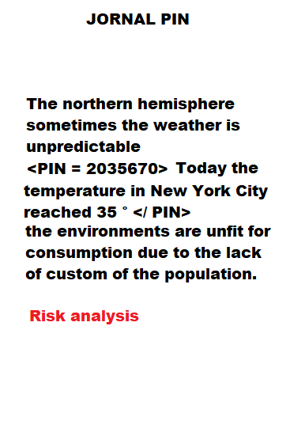
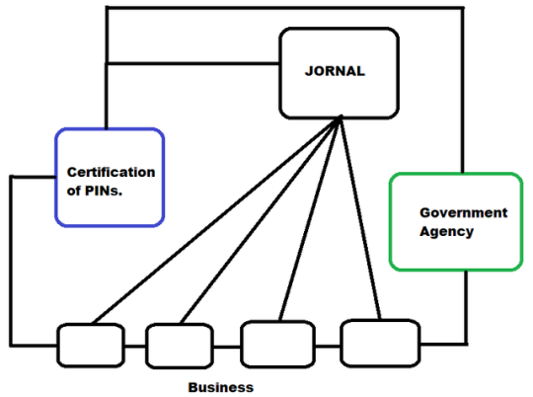

“When a text-processing user evokes a TAG PIN, journalistic software automatically launches in front of the pin the accepted text-format options, such as pre-print measures that should only receive the information collected and delete the excess elements for the PIN to be validated by the software to represent a value to be transacted for robots along with the business.”
— Max Diniz Cruzeiro

#world #brasil

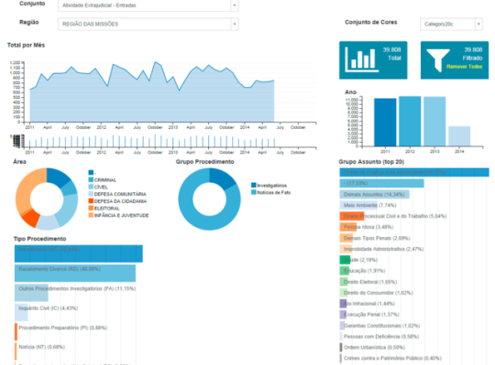

Newspapers feed with the TAG PINs available panels in the companies automatically. Newspaper and business employees become analysts and information managers each at their professional level.

#world #brasil

“The value of the PIN is due to the rarity of finding information. The use of a PIN requires a contract with the supplier.”
— Max Diniz Cruzeiro

#world #brasil

“The PIN software activates the specific libraries according to theme, subtitle, reporting area, theoretical group of a particular knowledge, … when the user-journalist plays in search of a sequence of ideas, a probability launches on the screen a set of PINs with formats available for transactions with their respective prices in which the user must choose what fits best in his pocket to sign contract with the PIN Certifier for the transfer of information. Business-mode software also has the freedom to choose PIN vendors according to the market’s offer.”
— Max Diniz Cruzeiro

#world #brasil

“Será que eu não mereço ganhar 5 passagens aéreas ida de volta para o Japão em agosto de 2020 com a estadia paga, não?”
— Max Diniz Cruzeiro
#world #brasil

Max Diniz Cruzeiro
QNJ 30 CASA 30 – Taguatinga Norte – Brasília/DF – Brazil
CEP.: 72140-300
+55 (61) 3475-6777 / +55 (61) 99967-3008
contato@lenderbook.com

