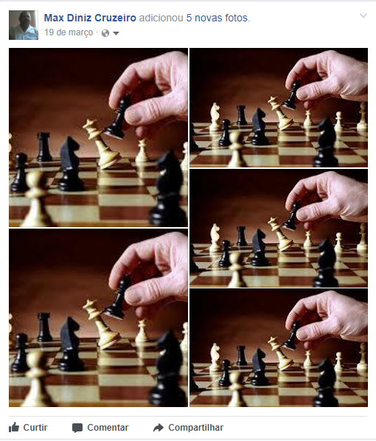

https://www.youtube.com/watch?v=kp5vR9RzVVg&t=8s

https://www.youtube.com/watch?v=sdAEbs54ZAY

https://www.youtube.com/watch?v=0Hqzx9sLJu0

https://www.youtube.com/watch?v=T0i2gFVIpWQ

https://www.youtube.com/watch?v=GEmuEWjHr5c

https://www.youtube.com/watch?v=GwvHi1Uj-ug

https://www.youtube.com/watch?v=8Y86RTjvARE

https://www.youtube.com/watch?v=W1qG0SAuRM8

https://www.youtube.com/watch?v=P2qPqf75p5w

https://www.youtube.com/watch?v=-a6WOspvzFE

https://www.youtube.com/watch?list=PLBcjnB4Ww0aDT52eSqmUJVe0CID5S4ccE&v=O_yGEslYa1k

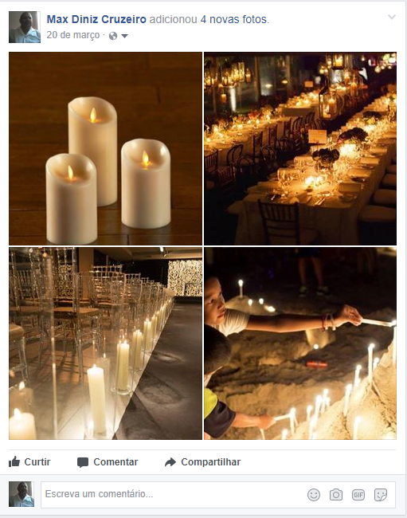

https://www.youtube.com/watch?v=GI-CwzVY-aA

https://www.youtube.com/watch?v=RelL-PdcCSk

https://www.youtube.com/watch?v=ZMGZQZRIsJE
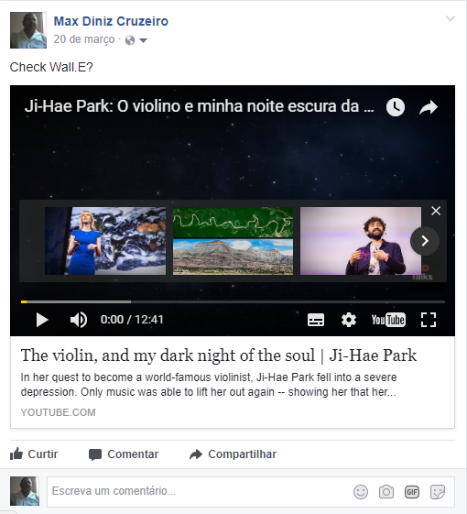

https://www.youtube.com/watch?v=ZMGZQZRIsJE

